Relangi Hema Phanendra Kumar Gowd
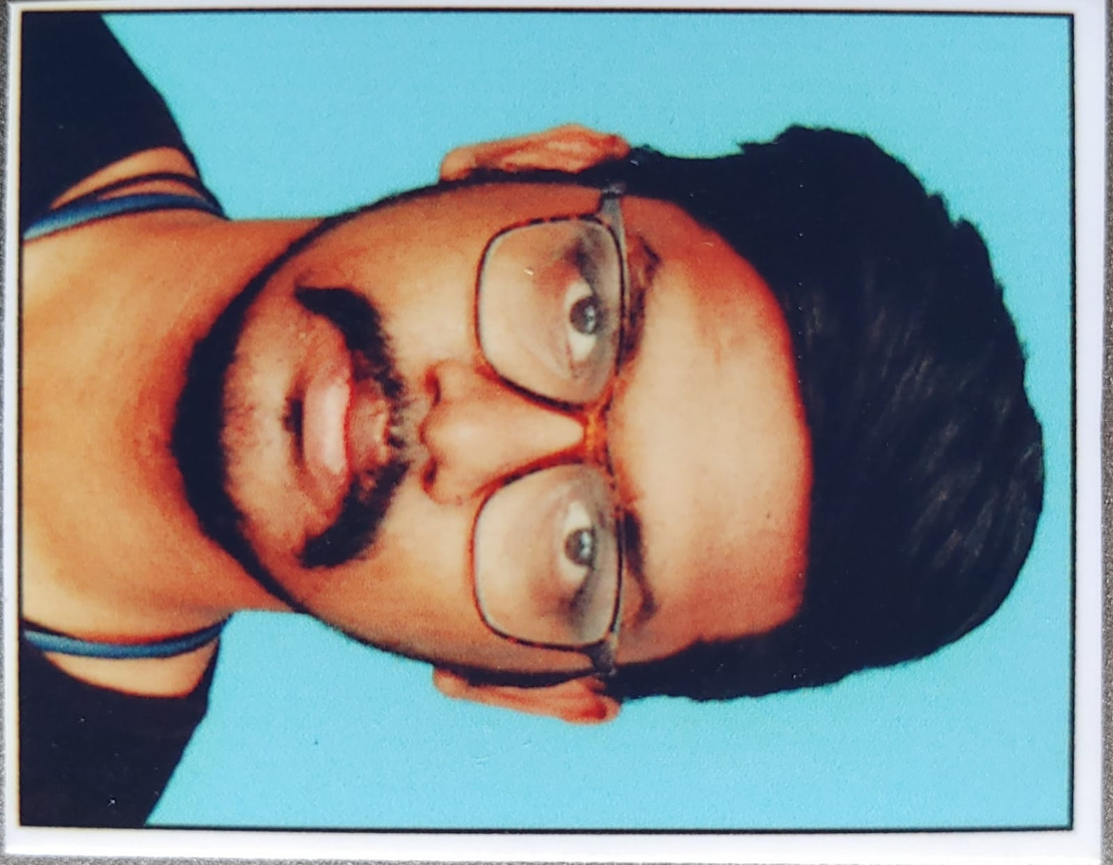

Title: | Senior Software Engineer
Location: | Rajahmundry
Languages: | Telugu(native), English

Experience Summary
- Having 2.5 + years of Experience in MS SQL Server.

- Experience in Manual Testing- Black box, Smoke, Regression and in writing Test Cases Understanding business requirements, Analyzing and streamlining requirements.

- Expertise in Manual Testing (Functional Testing, Integration Testing, System Testing, Regression Testing, Sanity Testing).

- Expertise in testing Web applications.

- Well versed with database concept and experience in using SQL statements.

- Well Versed with Software Development Life Cycle (SDLC) and Software Testing Life Cycle (STLC) Including Agile Methodology.

- Extensively worked on Writing Test Cases, Execute Test Cases, Logging Defects, Defect Tracking and Prioritize Defects.

- Good knowledge on Defect Tracking tool JIRA. Trainings provided for new joiners
KEY SKILLS:
- Technical: Ms SQL, SSRS,
- Software Testing: Manual Testing

Experience
01 | Type of Industry: | Marketing
 | Project Description: | Data ingress gathered From the different Vendors and orchestra the data and  Egress the data keep the data For available for the Reporting Tools and synapses servers and storing the data in Cool storage
 | Role/Title: | Senior Software Engineer
 | Project Duration: | 9 Months
 | Responsibilities: | - Generated Scripts for Data On boarding  - Generated Daily and Weekly Reports  Monitoring the running Daily activities for any failures and blockers  - Worked on the DDL & DML Validation and modification for the target database compatibility  Performed bulk data load on the target database including the data validation
 | Operating Systems: | Windows 10
 | Software / Languages: | Basics Of Python, Html & CSS
 | Special Tools: | ADF, SSMS, Azure DevOps For Agile Methodology, Azure Data bricks

02 | Type of Industry | Insurance
 | Project Description: | Data Extraction  Data retrieving From Source tables  Comparing and verifying the Data
 | Role/Title: | Software Developer
 | Project Duration: | 2 years
 | Responsibilities: | - Having good knowledge in data movement and organization (IMPORT, EXPORT, LOAD), having good knowledge on Team/Workload Management.  - Generated the DDL & DML Scripts for all the DB Objects.  - Worked on the DDL & DML Validation and modification for the target database compatibility. Deployed the database scripts for the creation of views & stored procedures
 | Operating Systems: | Windows 10
 | Software / Languages: | Basics Of Python, Html & CSS
 | Special Tools: | SSMS, SSRS

Training, Certifications & Affiliations
- Azure AZ900

Higher Education
Bachelor of Technology in Jawaharlal Nehru Technological University Affiliated College.

